Spesifikasi Kemasan

Nama Produk : ZOI Ilios 5000 Series Surgical Light - Single Dome Mobile Type
Tipe : ZOI-SL-IL-5100M

- Label
  - Label penandaan ZOI Ilios 5000 Series Surgical Light - Single Dome Mobile Type
- Bahan : Stiker Vinyl
- Warna Label : Putih
- Warna Teks : Hitam
- Ukuran : 90 x 60 mm (p x l)

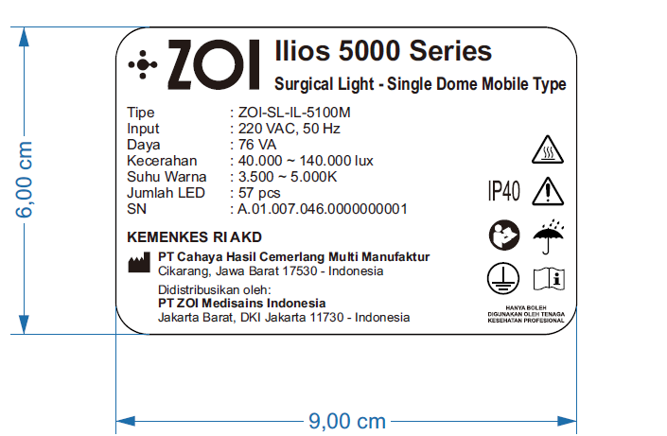
Gambar 1. Label Penandaan ZOI Ilios 5000 Series Surgical Light - Single Dome Mobile Type

- Kemasan
  - Wooden Box ZOI Ilios 5000 Series Surgical Light - Single Dome Mobile Type
    - Bahan : Kayu
    - Bentuk : Kotak
    - Warna : Natural/kayu/Coklat
    - Ukuran : 115 x 115 x 65 cm (p x l x t)

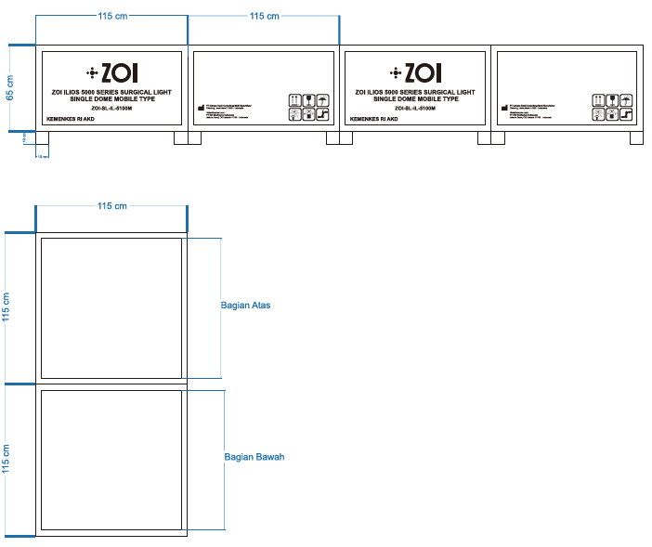

Gambar 2. Wooden Box ZOI Ilios 5000 Series Surgical Light - Single Dome Mobile Type

  - Corrugated Box Head Lamp ZOI Ilios 5000 Series Surgical Light - Single Dome Mobile Type
    - Bahan : Corrugated
    - Bentuk : Kotak
    - Warna : Coklat
    - Ukuran : 105 x 100 x 25 cm (p x l x t)

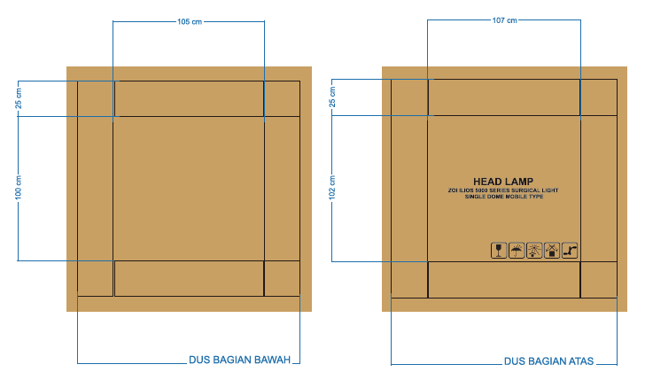

Gambar 3. Corrugated Box Head Lamp ZOI Ilios 5000 Series Surgical Light - Single Dome Mobile Type

